Gîtes de France Les Barmés & la Bartavelle
Champagny en Vanoise - France
How to get to Champagny en Vanoise...
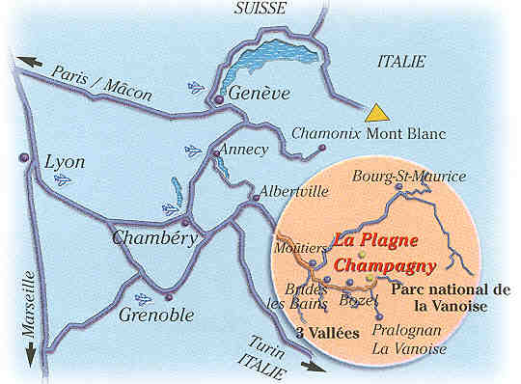 | ♦ By car :  700 km from Paris  200 km from Torino  965 km de Brussels  175 km de Lyons  140 km de Geneva  ♦ By plane :  175 km Lyon St. Exupéry Airport  100 km Chambéry Airport  140 km Geneva Cointrin Airport  ♦ By train :  S.N.C.F Station: Moûtiers (18km), then transfer by scheduled coaches or by taxi.  Eurostar* : direct lines from Great Britain.  Thalys* : Amsterdam, Bruxelles, Moûtiers  * running during the winter season.

How to get to your Gîte ?
Chalet de
La Bartavelle

